**Difference Between A/L education & University Education,Are Kuppi Classes Really Necessary...?**

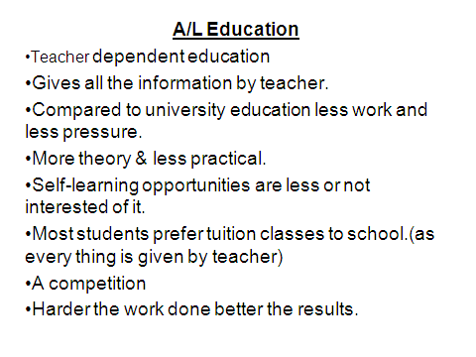

Deficits in A/L education

* Inadequacy of proper guidance
* Teacher dependent education
* Spoon feeding
* Less practical knowledge
* Poor active and self learning

How can we improve the A/L education ?

* Provide objectives for each subjects
* Encourage students to gather Knowledge from text book and internet
* Encourage group discussions
* English medium ?
* Student presentations

University Education :- Problems

* Transformation from spoon fed (passive) education to active education.
* Applied sciences are job oriented.
* Language difficulties.
* Clinical medicine vs pre clinical education.
* Social issues regarding fraternities or sororities.
* Being away from home.
* Economical problems.
* Political views**.**

**Kuppi Classes**

* Kuppi classes give significant amount of knowledge to the student.

But that does not provide knowledge to address a specific clinical problem.

* With the knowledge gained through the Kuppi classes student may face the exams with some confidence.

But they may write unnecessary things which are not relevant to the questions & failed in time management.

Disadvantages of kuppi classes

1. Kuppi teacher is also a student, and if he misunderstood something else, then it can be taught us in the same manner.
2. Kuppi teacher has no full confident enough to explain theory problems accurately.
3. As far as student think that they can go through exams with the help of kuppi class, there's a tendency to get absent from the lectures.
4. Because of that students lack long-term memory.
5. Kuppi teacher is not aware about the important theory points as well as the unnecessary things. There fore all the points are taught
6. most of students are able to get only just passes as they can’ get thorough knowledge from the kuppi classes.
7. As the kuppi classes are conducted in Sinhala medium, students neglect English.

Suggestions

.) Encourage Group discussions among university students

2.) Encourage E-learning by provision of facilities

3.) Audio- visual Library facilities

4.) Revision sessions after finishing each module/ each appointment

5.) Open Book tests

6.) Pre & Post Unit assessments in MCQs , Essay Qs & clinical component.

* *Group Discussions*
  + Allow students to share their knowledge
  + Stimulate students to read around a specific topic
  + Encourage students for pre preparation regarding particular subject matter
  + Allow students to clarify their doubts
  + Allow students to understand difficult topics through an argument
  + Allow students to remember subject matter in a logical manner
* *E- learning*
  + provides easier access to a particular subject
  + Can learn subject matter with audio-visual educational aids
  + Easy to understand
  + Stimulates students to gather some additional knowledge
  + Encourage students in research topics
  + Easiest way to clarify their doubts
  + Stimulate students to think

**Conclusion**

* A/L
  + School and Tuition base education
  + Mainly passive learning….Hardly any active part
  + Had enough time for extra curricular activities
  + No division among students, other than gender difference
* University
  + Lectures, Practical and Skill base education
  + Good portion of active learning
  + Time for extra curricular activities…..?
  + Divisions among students…????

KUPPI” Classes

* What does the “Kuppi” means?
* It resembles the **æÞûßûÚ Ù$ÈûÕ<,** not a huge flash light or any other bright object which give you a good bright light. It gives only a tiny light for the people who are in the darkness.

**What they say…..(what we have experienced)**

This knowledge is not enough`

Im not an expert, Im explaining what I have understood

This wont give u a good result in the exam, so Please go and read

* Only in 1st year, Occasionally can be seen in 2nd year and hardly in later years and it gradually convert in to group discussions.
* No clinical case discussions in kuppi classes, they explain mainly the lecture notes and as there are no any kuppi classes after 2nd year they have to find their own way to survive, most of the students choosThank you………..
* e small group discussion as their method of learning.